JBB20150120

**BPM-5 Motor Operating Sequences**

Sequences

A. Hard Safe 3

B. Soft Safe 4

C. Prop. Loading & Checkout 5

D. Nominal Ignition 7

E. Prestage/Mainstage 9

F. Nominal Shutdown 10

G. Pre-run Abort 11

H. In-run Abort 12

I. Transport Configuration 13

# Document Change record

|  |  |  |  |  |
| --- | --- | --- | --- | --- |
| Version | Date | Changed paragraphs | Remarks | Author |
| 0.1 | 16/12-2014 | - | New release | JBB |
| 0.2 | 20/01-2015 | All | Revised edition following review | CS Engine Group |

# Operating examples:

Nominal hot-fire test: **B → C → D → E → F → B**

Hot-fire test aborted due to overpressure on P1 during ignition sequence: **B → C → D → G → B**

Hot-fire test aborted due to pad fire in Mainstage: **B → C → D → E → H → B → A**

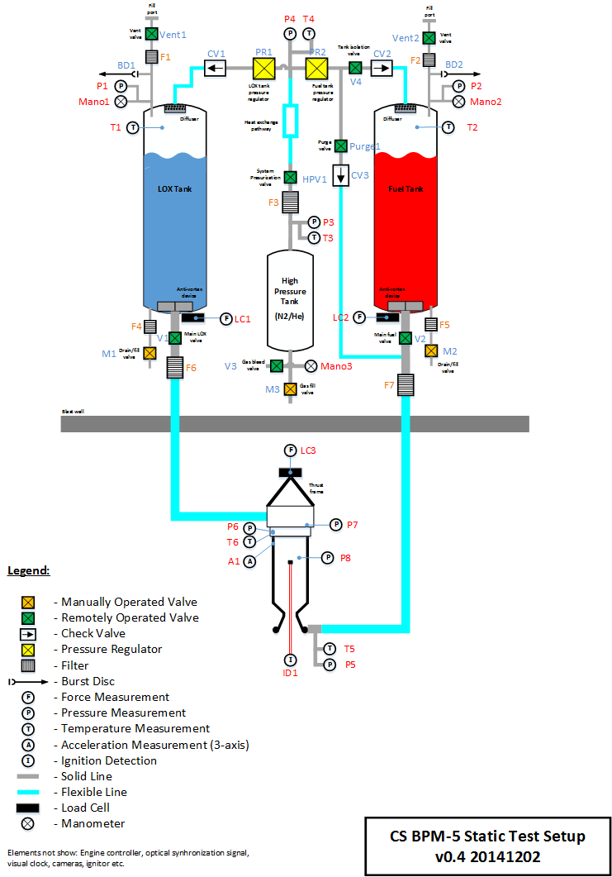

Figure 1: BPM-5 test stand with valve and sensor reference numbers.

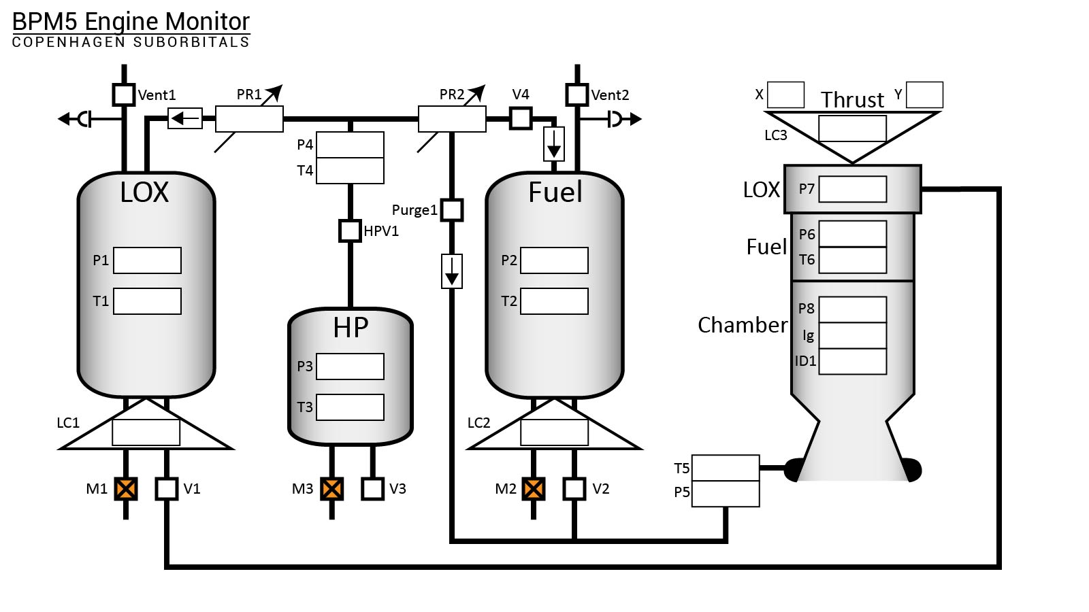

Figure 2: Graphical overview of test setup used for online monitoring.

# Hard Safe

This sequence serves to put the test stand and motor into an inherently safe state with the high pressure tank fully depressurized. Sequence to be commanded separately from normal operating flow **only**, e.g. in the case of fire on the test stand. This means that Hard Safe MUST always be preceded by Soft Safe.

|  |  |  |  |
| --- | --- | --- | --- |
| **Step No.** | **Time** | **Description** | **Action** |
| **A1** | - | Vent high pressure tank | * Open V3. * Verify P3 dropping. |
| **A2** | - | Vent high pressure branch of feed system | * Verify P3 at atmospheric pressure. * Open HPV1. * Verify P4 dropping. |
| **A3** | - | Seal off high pressure branch | * Verify P3, P4 at atmospheric pressure. * Close V3. * Close HPV1. * Close PR1, PR2. |

# Soft Safe

This sequence serves to put the test stand and motor into an inherently safe state while retaining the full operating pressure of 200 Bar (**TBC**) on the high pressure tank and the content of the oxidizer/fuel tanks. Sequence to be commanded automatically as part of the overall test stand operating procedure.

|  |  |  |  |
| --- | --- | --- | --- |
| **Step No.** | **Time** | **Description** | **Action** |
| **B1** | - | Default valve positions | * Close V1. * Close V2. * Close V3. * Close V4. * Close HPV1. * Close Purge1. * Close PR1. * Close PR2. * Open Vent1. * Open Vent2. |

# Prop. Loading & Checkout

The propellant loading and checkout sequence encompasses all steps required to bringing the system from Hard/Soft Safe condition to an ignition ready state. **If returning from Hard Safe begin sequence from step C1. If returning from Soft Safe or high pressure tank is already filled to target operating pressure, proceed from step C5.**

|  |  |  |  |
| --- | --- | --- | --- |
| **Step No.** | **Time** | **Description** | **Action** |
| **C1** | - | Verify high pressure tank is not pressurized | * Read P3/Mano3, if pressurized proceed to C4. |
| **C2** | - | Cycle HPV1 and V3 with manual verification. | * Open/close HPV1 and verify. * Open/close V3 and verify. |
| **C3** | - | Prepare for pressurization gas loading | * Close V3. * Close HPV1. * Close PR1. * Close PR2. |
| **C4** | - | Load pressurization gas into high pressure tank and seal tank. Target pressure 200 Bar (**TBC**) | Perform manual loading procedure.   * Close M3.   Verify and record correct pressure by P3 remote reading and Mano3 manual reading. Sensor readings should agree to <1 Bar (**TBC**). Verify no pressure rise in P4, and no pressure drop on P3/Mano3 over a 1 minute period |
|  |  |  |  |
| **C5** | - | Remove Before Firing (RBF) pin is inserted in HPV1 | RBF pin is manually inserted to mechanically restrict movement of HPV1. |
| **C6** |  | Verify RBF pins are not inserted into V1 and V2 | Manually inspect V1 and V2 to ensure RBF pins not inserted. If RBF are inserted, remove them. |
| **C7** | - | Cycle all remote controlled valves except HPV1 and V3 with manual verification. Controlled from MC-box and verified by manual inspection on test stand.  **FIND WAY TO VERIFY PR1 AND PR2 MOVEMENT JBB20150119** | * Verify HPV1 closed. * Open/close V1 and verify. * Open/close V2 and verify. * Open/close V4 and verify. * Open/close Purge1 and verify. * Open/close Vent1 and verify. * Open/close Vent2 and verify. * Open/close PR1 and verify. * Open/close PR2 and verify. |
| **C8** | - | Prepare for propellant loading | * Close V1. * Close V2. * Close V4. * Close Purge1. * Open Vent1. * Open Vent2. |
| **C9** | - | Remove Before Firing pins inserted into V1 and V2 | * RBF pins are manually inserted to mechanically restrict movement of V1, V2 * Verify RBF pin inserted into HPV1. |
| **C10** | - | Record all sensor readings, to form system configuration state vector and null load cells | Verify all sensor readings within limits, i.e. all sensor operational. |
| **C11** | - | Load target mass of (**TBD**) kg Fuel through M2 | Manual loading procedure. Verify loaded mass by load cell LC2 reading. Loaded mass shall be within (**TBD**) kg of target.   * Close M2. |
| **C12** | - | Load target mass of (**TBD**) kg LOX through M1 | Manual loading procedure. Following loading, allow tank to thermalize for (**TBD**) minutes. Verify loaded mass by load cell LC1 reading. Loaded mass shall be within (**TBD**) kg of target.   * Close M1. |
| **C13** | - | Verify ignition detect circuit operation | * Manual test of ID1. Sensor response must be verifiable. |
| **C14** | - | Verify igniter continuity |  |

# Nominal Ignition

Sequence to be performed when performing the terminal count followed by nominal ignition. Sequence must be preceded by the propellant loading and checkout sequence. Nominal ignition stepwise procedure is as follows:

|  |  |  |  |
| --- | --- | --- | --- |
| **Step No.** | **Time** | **Description** | **Action** |
| **D1** | **-** | Top-off LOX tank to target LOX mass + (**TBD**) kg | Manual top-off loading procedure to replenish tank. Verify loaded mass by load cell LC1 reading. Loaded mass shall be within (**TBD**) kg of target.   * Close M1. |
| **D2** | T-240s | High Speed imaging startup | Verify all camera systems operating. |
| **D3** | T-230s | Remove Before Firing pins removed, igniter IBF shunt inserted | * RBF pins are manually removed from V1, V2 and HPV1. * Insert igniter IBF pin shunt. * Remove igniter RBF pin short. |
| **D3** | T-180s | Pad evacuation | All test personnel retreats from Pad to designated safe positions. |
| **D4** | T-125s | Configure tanks for pressurization | * Close Vent1 * Close Vent2 * Close Purge1 |
| **D5** | T-122s | Start monitoring of P1 | * Read P1, if pressure above (**TBD**) Bar open Vent1 until P1 pressure below (**TBD**) Bar. |
| **D6** | T-120s | Scheduled hold, duration 60 seconds (**TBV using the cold flow test**) | Verify autogeneous pressure rise on P1. |
| **D7** | T-65s | Arm igniter circuit |  |
| **D8** | T-60s  (TCS - Terminal Count Start) | Pressurize tanks to intermediate pressure level, and verify pressure holding | * Open V4. * Open HPV1, verify pressure at (**TBD**) Bar on P4. * Operate PR2, verify steady intermediate pressure at (**TBD**) Bar on P2. * Operate PR1, verify steady intermediate pressure at (**TBD**) Bar on P1. |
| **D9** | T-10s | Pressurize tanks to test pressure level and verify pressure holding | * Operate PR2, verify steady test pressure at (**TBD**)± (**TBD**) Bar on P2. * Operate PR1, verify steady test pressure at (**TBD**)± (**TBD**) Bar on P1. |
| **D10** | T-3s | Ignition | * Fire igniter. Exact timing (**TBV**) under EC checkout test |
| **D11** | T-1s to T-0.5s | Verify igniter operation | * ID1 gives clear indication of igniter having fired. |

If any verification fails, revert directly to **Pre-run Abort** sequence.

# Prestage/Mainstage

Once positive ignition has been achieved, the motor transitions via prestage to mainstage operations. The associated sequencing follows a stepwise procedure as outlined below:

|  |  |  |  |
| --- | --- | --- | --- |
| **Step No.** | **Time** | **Description** | **Action** |
| **E1** | T-0s | Main LOX valve opens to prestage position | * Open V1 to 10% (**TBC**) of full flow. * V1 valve actuator encoder verifies valve partially opened. |
| **E2** | T+0.3s (**TBV**) | Main Fuel valve opens to prestage position. Slight LOX lead targeted to avoid hardstarts due to fuel blowback in LOX feed system. | * Open V2 to 10% (**TBC**) of full flow. * V2 valve actuator encoder verifies valve partially opened. |
| **E3** | T+0.8s | Verify prestage ignition | * ID1/P8 gives clear indication of prestage ignition. |
| **E4** | T+0.9s | Main LOX and main Fuel valves roll to fully open simultaneously | * Open V1 to 100%. * Open V2 to 100%. * V1, V2 valve actuator encoders verify valves fully open. |
| **E5** | T+1.5s (**TBC**) | Release vehicle from hold-down mechanism (**flight only**) | * Verify chamber pressure P8 at (**TBD**)± (**TBD**) Bar. * Fire release pyros. |
| **E6** | T+2.0s → | Continuous motor monitoring and, if applicable, DPR-based O/F control via P4 → P1, P2 trimming | * Operate PR1 using P1 and P4 as inputs. * Operate PR2 using P2 and P4 as inputs. * Continuously monitor P5, P6, P7, P8, A1, T5, T6. After T+12s (**TBC**)continuously verify readings remain in their acceptable intervals, otherwise perform in-run abort. |

If any verification fails, revert to **In-run Abort** sequence.

# Nominal Shutdown

If the system is not trimmed to a full/partial depletion shutdown, a nominal shutdown must take place with propellant remaining in the tanks. Such a shutdown sequence involves the following steps:

|  |  |  |  |
| --- | --- | --- | --- |
| **Step No.** | **Time** | **Description** | **Action** |
| **F1** | TS-0s | Terminate fuel flow | * Close V2 . * Close V4. |
| **F2** | TS-0.2s (**TBC**) | Purge fuel branch | * Verify V2 closed. * Set PR2 to P5 target pressure 5 Bar (**TBC**). * Close PR1. * Open Purge1. |
| **F3** | TS-0.5s (**TBC**) | Terminate LOX flow | * Close V1. |
| **F4** | TS-4.0s | Terminate Purge | * Close HPV1. * Verify P4 dropping. |
| **F5** | TS-6.0s | Seal off high pressure branch | * Verify P4 at atmospheric pressure. * Close PR2. |
| **F6** | Ts-7.0s | Vent LOX tank | * Open Vent1. |
| **F7** | Ts-13s | Vent Fuel tank | * Open Vent2. |
| **F8** | >Ts-60s | Verify all pressures are within limits (**TBD**) before returning to PAD. | * If any pressure verification fails, revert to soft safe. |

If any verification fails, revert to **In-run Abort** sequence.

# Pre-run Abort

Sequence to be executed automatically in the event of an abort being called within the interval from step D4 to step D10.

|  |  |  |  |
| --- | --- | --- | --- |
| **Step No.** | **Time** | **Description** | **Action** |
| **G1** | - | Disarm igniter circuit |  |
| **G2** | - | Abort pressurization | * Close PR1 * Close PR2 * Close HPV1 * Close V4 * Open Purge1 |
| **G3** | - | Vent LOX tank | * Open Vent1 * Verify P1 dropping. * Delay 6s |
| **G4** | - | Vent Fuel tank | * Open Vent2 * Verify P2 dropping. |
| **G5** | - | Vent high pressure branch | * Open PR2 * Verify P4 dropping. |
| **G6** | - | Seal of high pressure branch | * Verify P4 at atmospheric pressure. * Close PR2. |

If any verification fails, revert to **Soft Safe** sequence.

# In-run Abort

Sequence to be executed automatically in the event of an abort being called within the interval from step E1 to step E6. Valves to be actuated with maximum speed.

|  |  |  |  |
| --- | --- | --- | --- |
| **Step No.** | **Time** | **Description** | **Action** |
| **H1** | TA-0s | Terminate fuel flow | * Close V2 (fast). * Close V4. |
| **H2** | TA-0.2s (**TBC**) | Purge fuel branch | * Verify V2 closed. * Set PR2 to P5 target pressure 5 Bar (**TBC**). * Close PR1. * Open Purge1. |
| **H3** | TA-0.5s (**TBC**) | Terminate LOX flow | * Close V1. |
| **H4** | TA-0.7s | Vent LOX tank | * Open Vent1 * Verify P1 dropping. |
| **H5** | TA-0.9s | Vent Fuel tank | * Open Vent2 * Verify P2 dropping. |
| **H6** | TA-6.0s | Terminate Purge | * Close HPV1 * Verify P4 dropping. |
| **H7** | TA-8.0s | Seal off high pressure branch | * Verify P4 at atmospheric pressure. * Close PR2. |

If any step fails, revert to **Soft Safe -> Hard Safe** sequences as a last resort.

# Transport Configuration

Prior to physically transporting the test stand between VTC3 and HAB, the test stand must be brought into a safe configuration. This involves a manual sequence of the following steps:

|  |  |  |  |
| --- | --- | --- | --- |
| **Step No.** | **Time** | **Description** | **Action** |
| **I1** | - | Manually drain and ventilate tanks. | * Open M1, drain remaining LOX. * Delay 5 minutes to ensure complete evaporation. * Open M2, drain remaining Fuel. |
| **II2** | - | Secure tanks and BPM-5 motor for transport. These items are connected to load cells which do not respond well to out-of-axis loads. | * Secure LOX tank to frame. * Secure Fuel tank to frame. * Secure BPM-5 motor to frame. |
| **I3** | - | Transport between VTC3 and HAB |  |
| **I4** | - | Remove securing of tanks and motor after transport. |  |